Protocol perfusions
- PFA preparation

- At least 1 day before the perfusions prepare 4 % paraformaldehyde (PFA) inside the hood (40 g PFA in 1 l PBS). Put a magnetic stirrer and put the stirring speed below “3” and the heath of the heating plate between “2 and 3”. Let it steer till afternoon or ON.
- When the PFA is dissolved, filter the solution with a filter paper and a funnel and put the filtered PFA in the fridge.

- Perfusion preparation
- Take the dissection materials needed out of the oven (tin box with dissection material)
- Put on the LAF/chemical cabinet by putting on both the LAF (fan symbol on cabinet) and the chemical flow (the button at the bottom right stand of the cabinet).
- Take the perfusion bags out of the fridge and fill the PFA bag:
  - Keep the bag upside down
  - Remove the plastic tube that closes the bag
  - Put the syringe where you just removed the plastic tube
  - Pour the PFA in the syringe so that the bag will be filled
  - Close the bag again with the plastic tube
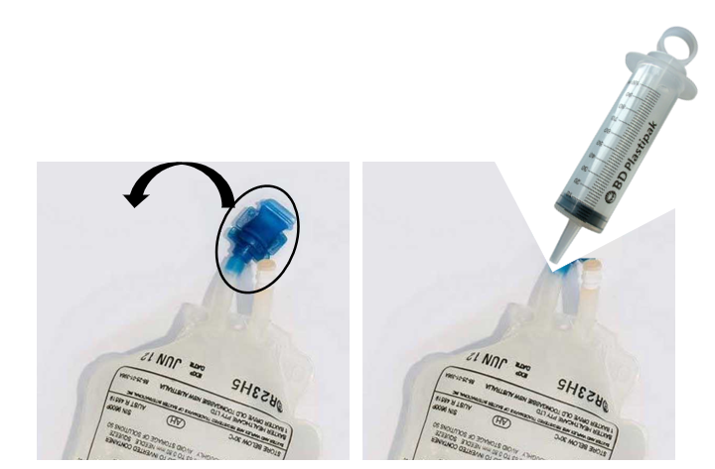
- Hang the bags on the hook next to the LAF/chemical cabinet, screw a 24 G needle (purple) on the saline and the PFA rubber cable and make sure the wheels of the 2 bags are screwed up (open position)
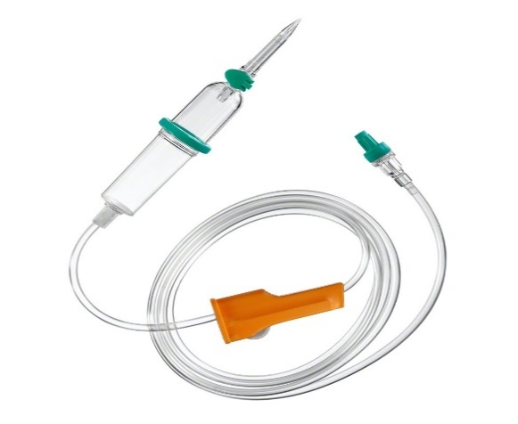
- Fill a number of cans, equal to the number of mice to be perfused, with PFA.
- Prepare the dolethal dilution to anesthetize the animals before perfusion. It is a 1/3 dolethal dilution in 0.9 % saline (1 ml dolethal in 2 ml saline). There is a bag of saline stored in the fridge and you can take the needed volume with a syringe with a needle.
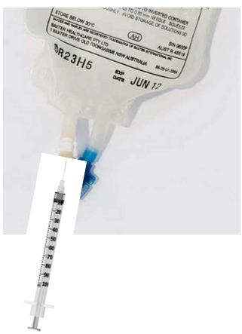
- Perfusion (https://www.ncbi.nlm.nih.gov/pmc/articles/PMC8005872/figure/BioProtoc-11-05-3988-v001/)
- Inject a mouse intraperitoneal with 180 µl dolethal dilution (for 2 mo, older mice with 200 µl dolethal dilution, for PND14 mice 25 µl) and wait a minute or 2.
- When the mouse lays down, bring it over to the cabinet and check it’s reflexes by pinching one of the hind paws with thick tweezers. If the responses are low, fix the mouse on a pile of thick tissues with 4 24 G needles.
- Start cutting only the upper skin by pulling the skin up with tweezers.
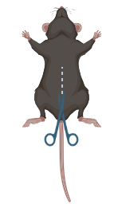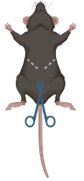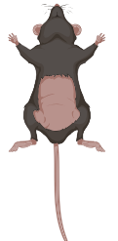
- Cut open the lower skin until you reach the diaphragm
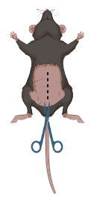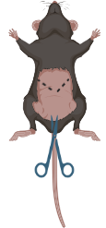
- Carefully cut open the diaphragm without damaging the surrounding organs. Cut the ribs at the side and place a clamp on the ribs to flip open the spot of the heart
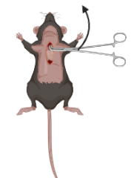
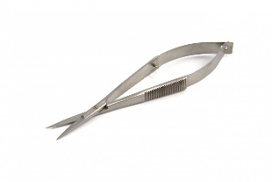
- Via the turning wheel, open the saline tap, carefully grab the heart with the tweezers and put the needle in the right bottom part (mouse left ventricle) of the heart. Cut the vein .on the other side of the hearth with spring scissors (you will see the blood coming out).
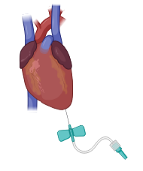
- Let the saline go through the blood vessels for a couple of minutes. You can check the liver, if it becomes brownish/white, the saline is flowing through.
- Switch to PFA via the turning wheel and let the PFA flow through the blood vessels. You can release one of the hind paws to check if it becomes stiff. Also the tail will move a bit if the PFA runs through.
- Turn of the PFA by using the stirring wheel.

- Dissection of the brain (same principle as with the dissections).

- Post fixation
Let the brain post fix overnight in PFA at 4 °C.
- Switch PFA to 0.1 % sodium azide in PBS and store the brains at 4 °C.

